SOUTH WEST AREA
INNOVATION AWARDS 2021

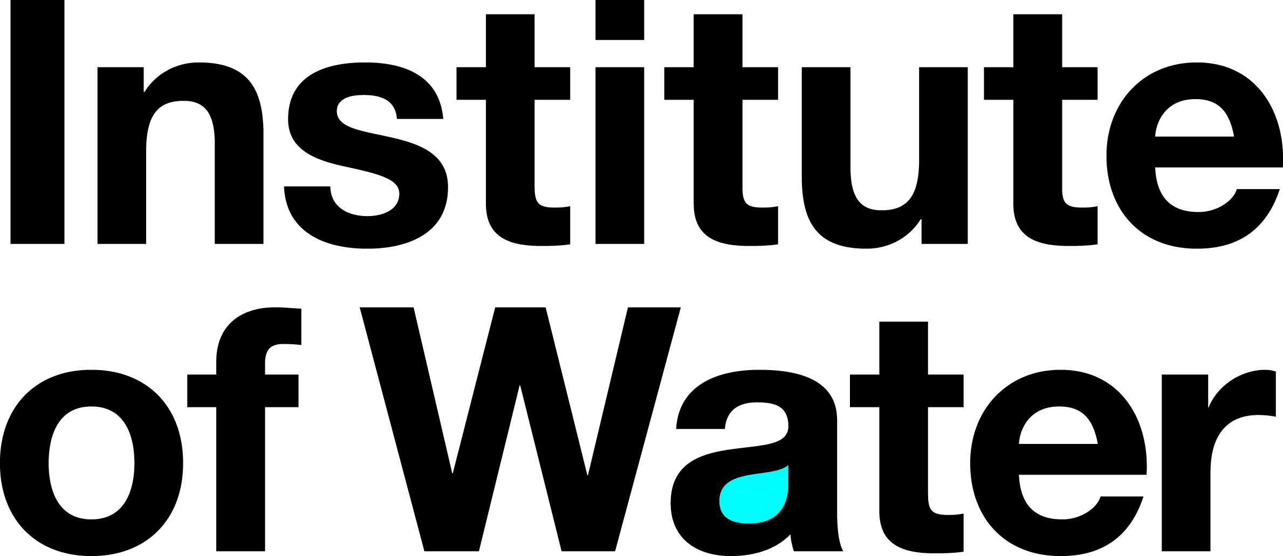
open to anyone operating within the South West Area
The winning entry will go forward to the National Innovation Awards – winners will be asked to produce a short (5-minute) video for the National Judging Panel
SUBMISSION
Applicant name (can be Company, Team or Individual):
Please note that this will be the Name(s) printed on the event media and any certificates awarded
Title of Innovation
Closing date for Submission |  | 19th March 2021
Point of contact for application (must be an individual)
Correspondence Address
Email Address
Phone Number
I believe this to be my/our innovation and I am unaware of any dispute around ownership
Signed
Entry Description

In no more than 100 words please can you describe your innovation.

For example, you may like to say a few words regarding the idea behind your innovation, how it was or will be executed and the benefits it has or will provide.

1. Overview - What are you doing/proposing and why? (Max 500 words)

This answer should contain a summary of the innovation; tell us what it is and what it does or what it will do. This answer should enable the assessors and judges to have a clear understanding of the innovation. Keep it as simple and self-explanatory as possible.

    - What are you doing or proposing to do?
  - Why are you doing it?
  - What are the key activities and timescales?
  - Where will it be developed/implemented?
  - What research have you undertaken to demonstrate its uniqueness/innovation?

Please provide evidence where available

2. Impact – Your results (Max 1000 words)

This essentially is the results of your innovation. You should highlight what achievements have been delivered to date or forecast future achievements. These can be qualitative or quantitative and displayed in tables, graphs, charts, e.g.

- Comparative data
- Financial data – costs and payback periods
- Direct benefits to the business such as changes in working practices, improved health safety and wellbeing, environmental impact and sustainability
- Changes in behaviour or culture such as improved morale, wellbeing, recycling
- Changes in reputation through advertisements, journal submissions
- Customer benefits

You should also outline how you plan to introduce your innovation to the market.

Please return completed form to Carmen Snowdon, South West Area, Area Rep
Carmen.snowdon@wrcplc.co.uk

