Computer systems architectures
CM12002
Russell Bradford
2023/24

1. History
We are now going to look at some history: this is useful as it will illustrate the many important parts of OSs and why they are necessary
At first, computers had no operating systems (1960s)
- Every programmer had to write their programs for the particular machine they were using
- So no portability
- And lots of repeated code between programs (“write a character to the teletype”)
Remember: the more we make programmers do, the more likely they are going to make a mistake

2. History
Furthermore, programmers rarely even saw the computer
- The program and the data is needed (collectively called a job) would be prepared on paper tape or punched card
- Jobs would be given to operators who would load and run them, collect the results and then send the results back to the programmer
- Usually, there would be a bug and the programmer would have to fix the program and go round the loop again
- As computer time was limited, there was an issue of scheduling jobs, initially done by hand
- Turnaround on jobs could be days
This concentrated the programmer’s mind wonderfully!

3. History
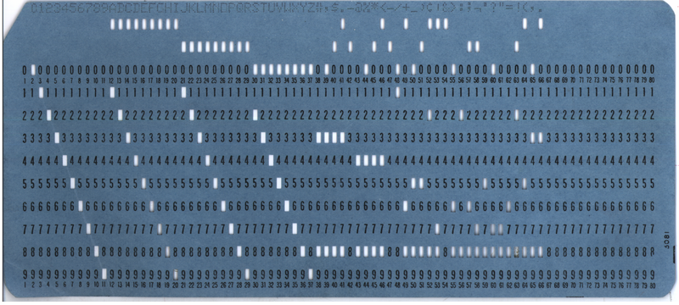
From Wikipedia. Encodes a single 80 character line

4. History
From Wikipedia. 5 and 8 hole paper tapes

5. History
It was soon found there was a lot of repeated code between programs, so useful tools (programs and libraries of code) were developed to help manage repetitive tasks
- collecting common functions in system libraries (sqrt, open file, etc.)
- program management (loaders)
- debuggers
- Interfacing to hardware: I/O drivers (send file to printer, etc.)
This made programming and program management easier, but there was still lots of human intervention needed

6. History
The issue was to keep the big and expensive computer as busy as possible, running programs all the time
Idle time was a waste of money
So the operators would load many programs on to a fast medium, such as magnetic tape, and the computer would load and run them as fast as hardware allowed
This was called spooling, the first instance of addressing the disparity between human and computer speeds

7. History
Spooling would also be used on output: the output would be written to a mag tape, which could then later be attached to a printer
Again, this was because printers are slower than computers

8. History
Of course, this was soon automated: have a little program, called a monitor (or supervisor), that loads programs from tape; runs them; and puts the results on tape
This would be directed by a job control language

9. History
A famous job control language from IBM was called JCL
Of course “JCL” means “Job Control Language”, but JCL was just one of a few job control languages

10. History
<+(0)->
//IS198CPY JOB (IS198T30500),'COPY JOB',CLASS=L,MSGCLASS=X
//COPY01 EXEC PGM=IEBGENER
//SYSPRINT DD SYSOUT=*
//SYSUT1 DD DSN=OLDFILE,DISP=SHR
//SYSUT2 DD DSN=NEWFILE,
// DISP=(NEW,CATLG,DELETE),
// SPACE=(CYL,(40,5),RLSE),
// DCB=(LRECL=115,BLKSIZE=1150)
//SYSIN DD DUMMY
(From Wikipedia) Any guesses?
This copies OLDFILE to NEWFILE
This would be set on 9 punched cards

11. History
A Fortran program, with data:
//CONVERT JOB USER=UGA001,MSGCLASS=6,NOTIFY=UGA001
//*MAIN CLASS=NITE,LINES=40,ORG=UGAIBM1.LOCAL
// EXEC FORTVCLG,REGION=2000K
//FORT.SYSIN DD *
READ(5,10) CENT
10 FORMAT(F6.2)
FAHR=(CENT*9.0/5.0)+32.0
WRITE(6,20) CENT,FAHR
20 FORMAT(F6.2,' CENT = ',F6,2,'FAHR')
STOP
END
/*
//GO.SYSIN DD *
100.00
/*
//

12. History
JCL allowed several programs to be collected and loaded together in a single bunch
This is called batch processing
Running in batches is more efficient, as we spend more time running our programs and less time messing around in the overheads of loading and unloading

13. History
This might seem like ancient history, but these things are still happening
Modern large computers are managed in just this way: and for the same reasons
We still run jobs and need to manage CPU usage and disk usage
Turnaround is seconds or minutes rather than days, but the principle is the same
Exercise look up Portable Batch System, PBS and compare with JCL

14. History
So the monitor was just a program there to help manage the machine
It would load an application into memory (from tape or wherever)
And then jump to the start of the application and start executing it
When the application finished, it would (be expected to) jump back to the monitor, so the monitor could deal with the next program

15. History
But if the application was badly written, it could overwrite the monitor
(90,10) (0,0)(15,10)Monitor (15,0)(10,10) (25,0)(30,10)User program (55,0)(35,10)
Machine memory
Either accidentally or deliberately
They needed to do something about this
But there are other problems, too

16. History
It was soon found to be more efficient to load more than one program into memory (when there was space)
(90,10) (0,0)(15,10)Monitor (15,0)(30,10)Program 1 (45,0)(30,10)Program 2 (75,0)(15,10)
The advantage being that if Program 1 was doing something like writing to a tape that takes a lot of time, but no CPU, the computer could run Program 2 in the meanwhile
When Program 2 pauses and Program 1 needs to run again, the computer could switch back to it
The decisions on what to run and actually doing the switching between programs was the job of the monitor

17. History
Now Program 1 could corrupt Program 2 as well as the monitor!
Or Program 1 could read confidential data out of Program 2
Some sort of protection of the monitor and other programs is needed
What happens if Program 1 goes into an infinite loop?
Control never returns to the monitor and Program 2 never gets to run
Some means of curtailing runaway programs is needed

18. History
So the “monitor runs the programs”: what does this really mean?
Nothing sophisticated. The monitor code just jumps to the program code so the machine is now running the program
Take care over this point: the monitor doesn’t sit and watch the program running, the monitor is not running while the program is running

19. History
(90,20) (75,0)(15,10)

Monitor runs Monitor jumps to program 1 Program runs Tape needed Program calls monitor Monitor sets up tape Monitor decides to run another program while waiting for the tape Monitor jumps to program 2 Program 2 runs Etc.

20. History
There is a single stream of control jumping between monitor and one or more programs
The monitor is not running when a user program is running, and the user program is not running while the monitor is running

21. History
This changing between multiple user programs is called multitasking. But only one thing is ever running
Multitasking improves the efficiency of use of a computer since while one program waits for a slow peripheral another program can run

22. History
So the monitor now needs to keep making decisions on which program to run next: it is scheduling the programs
The choices can be made according to many criteria
- how long a program has been running
- a priority of a program
- whether a program is likely to need CPU very soon, or can wait
- how much the owner of the program has paid
- And many more things

23. History
Early scheduling algorithms were very simple, e.g., keep running the same program until it’s done; later algorithms tried to be more clever
Some programmers would write their programs to take advantage of deficiencies in the scheduling algorithm: in the worst case starve other programs of any CPU time at all!
It is tempting to make the scheduling algorithm complicated: but remember more time spent in the monitor deciding what to schedule next is less time for the programs
So there is a trade-off of making scheduling fast but fair
This is still an issue today: we’ll look a little into scheduling later

