Comparative Programming Languages
CM20318
Russell Bradford
2023/24

1. Styles
So far you may be aware of a few styles of programming:
- Object Oriented style programming: Java and others, where you structure your code about objects (and classes)
- Procedural style: C, Python and others, where you structure about procedures (functions)
- Functional Style: Haskell and others, where you structure about higher order functions in a tightly controlled manner
- Declarative style: Prolog and ASP (and Haskell), where you structure about the things you want to be true or want to happen
- No style: unstructured things like assembly language, where there is no support for structuring

2. Styles
You will have spent a lot of time on procedural and object oriented
The declarative and functional should be covered in other Units at some point
But the point is there are many styles of programming

3. Styles
A “style” is an approach to programming or an aspect of the design of a programming language that is meant to make it easier for you to write correct programs
It is easy to write small programs in a slapdash manner: you can get away with it as you can hold the whole program in your head
When projects get large you cannot do this

4. Styles
The code gets too large for you to remember all the details
Or there are multiple people working on the code
So styles are invented to direct the way you write code so to make large systems written by many programmers possible

5. Styles
They encapsulate detail into blobs to help you keep a grasp on what is happening in your program
You then think “at a higher level” using blobs
Those blobs might be objects, modules, functions or other things
Roughly speaking, the nature of the blobs is what distinguishes between the various styles
But they all strive to make programming simpler and to control complexity
And make writing correct programs easier

6. Styles
If we had perfect programmers, then none of this structuring would be strictly necessary
Structure is a way of helping 3rd rate programmers to produce 2nd rate quality code
James Davenport (probably)
Programmers make mistakes. So how can a programming language help the programmer to make fewer mistakes?

7. Styles
Debugging is twice as hard as writing the code in the first place. Therefore, if you write the code as cleverly as possible, you are, by definition, not smart enough to debug it
Brian Kernighan
The errors you can spot easily are not the ones you need to worry about
Anon
Programmers should be lazy and stupid
Me

8. Styles
Programming languages themselves do have a role to play in making things easier for the programmer
Or harder, if they are bad things or habits
Unfortunately, there is no single programming language that does everything well

9. Styles
There are still people out there that think their favourite programming language is perfect and try to support it by saying that “it’s the programmer’s fault” or “they weren’t using the correct features” when something goes wrong
For examples, see C and memory management; and C++ and almost any feature
In 2010, the iPhone 4 had problems with reception. Apple’s response was essentially “you are holding it incorrectly”

10. Styles
If you have a hammer, everything looks like a nail
If you have Java, everything looks object oriented
Anonymous

11. Styles
One thing to remember before we start: programming styles are not exclusive
You can write in a procedural style in Java
—though Java makes it hard to do so easily
You can write in an OO style in C
—though C doesn’t really provide the constructs for you to do so easily
Though it may still be worthwhile to structure your C code around OO ideas
Both Java and Python (and many others) have OO and procedural aspects

12. Styles
Some languages support certain styles
Java was designed from scratch to be OO (to the extent of making it hard not to use objects)
Other languages allow you to use a style, but you have to do the twiddly bits yourself
You can program OO in C, but you have to do the “method” lookup yourself, i.e., pick the code for the right “method” yourself in your program
Sometimes this is good as it allows you to optimise for the problem in hand
Java provides a general mechanism (that you don’t see) for method lookup that has to work for all kinds of situations

13. Styles
From the other direction, some problems lend themselves better to a certain style
For example, a GUI application with windows and click boxes would be naturally OO
For a heavily numerical application, such as a weather forecasting, objects would be just a hindrance to coding

14. Styles
So some problems naturally suggest a choice of language to use to implement them
Others problems are near impossible to program regardless of style
Part of being a Computer Scientist is knowing these styles and knowing which languages support them
And then picking a style for a problem, then a language that supports that style
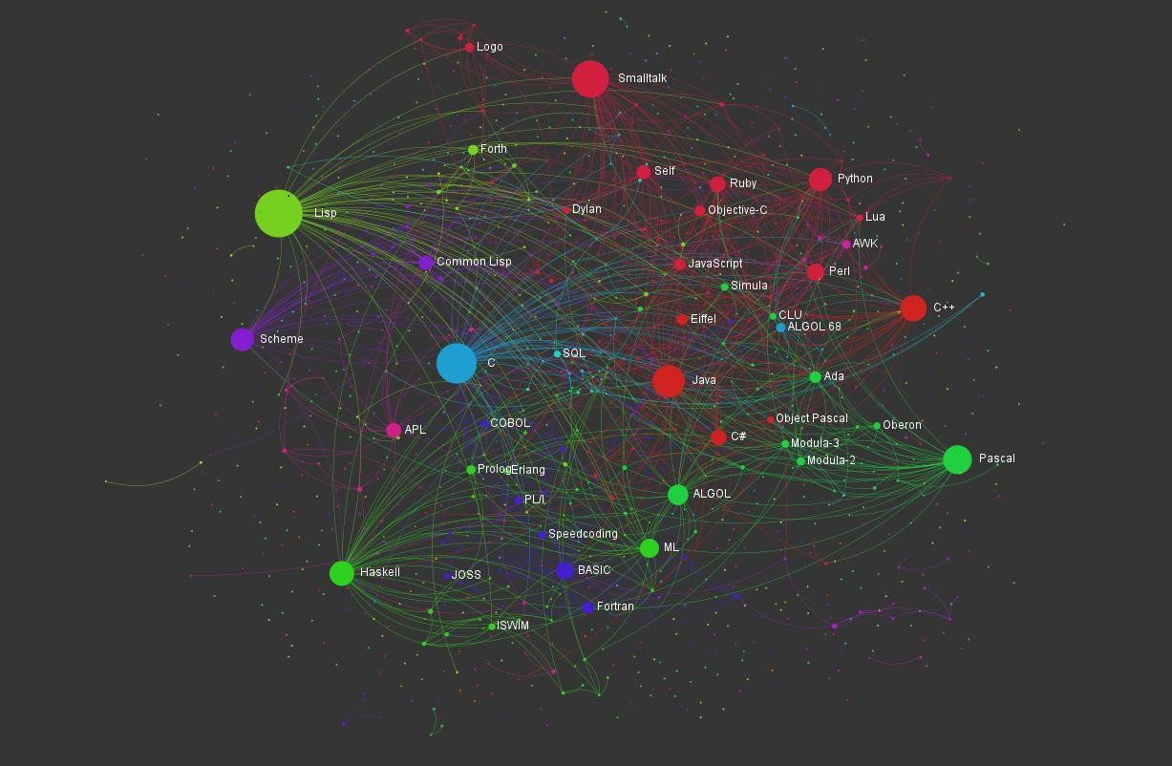
Programming Languages Influence Network

15. Language Families
From
https://exploringdata.github.io/vis/programming-languages-influence-network/
an interactive, zoomable map of languages

16. Language Families
Out there in the real world there are very many programming languages
How many are actually useful is a difficult question
Creating new languages is easy these days (go to a compilers unit!)
But designing a good and useful new language is much harder
And almost always unnecessary

17. Language Families
Most “new” languages are modest variants on existing languages, often emphasising some features of interest to the language designer
Very few have a radical new idea or approach
Thus languages tend to fall into families, where members of the same family have many features in common

18. Language Families
You may have already seen (or will soon see)
- C: procedural
- Haskell, Lisp: functional
- Prolog, ASP: logic
- Python: procedural and scripting
- Java: object oriented
- etc.
Families are not clearly separated: they are fuzzy at the edges

19. Language Families

Feet
- C: you shoot yourself in the foot
- Lisp: You shoot yourself in the appendage which holds the gun with which you shoot yourself in the appendage which holds the gun with which you shoot yourself in the appendage which holds…
- Prolog: You tell your program you want to be shot in the foot. The program figures out how to do it, but the syntax doesn’t allow it to explain
- Python: You try to shoot yourself in the foot but you just keep hitting the whitespace between your toes

20. Language Families

Feet
- Java: You locate the Gun class, but discover that the Bullet class is abstract, so you extend it and write the missing part of the implementation. Then you implement the ShootAble interface for your foot, and recompile the Foot class. The interface lets the bullet call the doDamage method on the Foot, so the Foot can damage itself in the most effective way. Now you run the program, and call the doShoot method on the instance of the Gun class. First the Gun creates an instance of Bullet, which calls the doFire method on the Gun. The Gun calls the hit(Bullet) method on the Foot, and the instance of Bullet is passed to the Foot. But this causes an IllegalHitByBullet exception to be thrown, and you die

21. Language Families
There are many many many programming languages
Some are used widely, but you don’t realise (Cobol, Fortran)
Some are not used much at all, but have been important influences on other languages (APL, Snobol, Algol)

22. Language Families

Feet
- Cobol: USEing a COLT 45 HANDGUN, AIM gun at LEG.FOOT, THEN place ARM.HAND.FINGER on HANDGUN.TRIGGER and SQUEEZE. THEN return HANDGUN to HOLSTER. CHECK whether shoelace needs to be retied
- Fortran: You shoot yourself in each toe, iteratively, until you run out of toes, then you read in the next foot and repeat. If you run out of bullets, you continue anyway because you have no exception-handling facility
- APL: You hear a gunshot and there’s a hole in your foot, but you don’t remember enough linear algebra to understand what happened.
- Snobol: If you succeed, shoot yourself in the left foot. If you fail, shoot yourself in the right foot

23. Language Families

Feet
Continuing Exercise go and read further around these (and other) languages to discover why they have these descriptions
Exercise for advanced students: make up jokes for the missing ones and funnier versions for existing ones

24. Language Families
There are hundreds of languages out there
How do we choose which to use?
Sometimes we are told by the boss, or have to fit with an existing project
Sometimes we only have a restricted choice

25. Language Families
If we have any choice we need to have some criteria to guide the choice
We need to able to
- identify and assess characteristics of a given language
- recognise similarities between languages
- recognise if a feature is unique to a language
- take concepts from one language to another (learn one, learn ’em all)

26. Language Families
“If you can’t say it you can’t think it” (Orwell/Wittgenstein)
Having more concepts allows more flexibility: for example, if there is no array construct in the language, you are restricted in what you can do easily
“Those who cannot remember the past are condemned to repeat it” (George Santayana)
Avoid re-implementation and old mistakes: wise people learn from the mistakes of others

27. Language Families
So to help think about concepts we classify language into families
But it is important to remember that families are not exclusive, a language can sit comfortably in more than one family

28. Aside
One of the many places where we will need to think about terminology is vectors and arrays
Sometimes people use these works interchangeably, to mean the same thing
Sometimes, not, e.g., array is fixed size, vector is variable sized
Or a vector is $1$D, an array is $>1$D
And sometimes people use “list” where others would use “vector”
There are many place in CS where people use different words for the same things; or the same word for different things. Be aware of such variations!

