Networking
CM30078/CM50123
Russell Bradford
2023/24

1. Networks
Networks form a central role in the way computers are used today: these days it is very hard to do anything that is not networked
As commerce and big money have taken over the Internet the nature of networking has changed from a way of linking together some CS departments to a multi-billion (trillion?) pound enterprise
Thus a good knowledge of what networks are and how they work is essential to any good Computer Scientist

2. Networks
And also to anyone who uses networks as part of their everyday activities
If more people realised quite how open, fragile and subvertable the Internet is, they would be a lot more circumspect in what they do on it!

3. Networks
The Internet is familiar to everyone here
But networks have been around for a long time
A network is any means to connect entities together so they can communicate

4. Networks
Reasons to network include:
- Resource sharing
- Communication and collaboration
- Information gathering
- Reliability through replication
- Entertainment

5. Networks
Existing networks include:
- The telephone system
- The mobile phone system
- TV and radio
- System control networks, e.g., Controller Area Network (CAN bus) in cars (and bicycles!)
- Sensor control networks, e.g., Bluetooth and ANT
- Cable (TV) networks
- The Internet

6. Networks
Metcalfe’s Law
The value of a network expands exponentially as the number of users increases
The bigger the network, the more links it has

7. Networks
There are many different kinds of network, thus meaning we need classifications to put things into easy boxes
But there are many classifications to choose from

8. Networks
Classification by size
- LAN Local Area Network
- MAN Metropolitan Area Network
- WAN Wide Area Network
- PAN Personal Area Network, WPAN (wireless PAN)
- and so on

9. Networks
Classification by speedspeed technology
- Narrowband
- Broadband
Actually these technical terms do not denote speed: their real meanings have been distorted by marketing
Optical fibre, while very fast, is actually technically narrowband
Exercise Find the technical meanings for narrowband and broadband

10. Networks
Marketing terms include:
- Broadband (xDSL)
- Fibre Broadband (xDSL)
- Full Fibre (fibre)
- Fast (?)
- Superfast (above 30Mbs)
- Ultrafast (above 300Mbs)

11. Networks
Classification by technology
- Voiceband modem (V series of standards, V.92)
- Local Wired (Ethernet)
- Medium distance wired. ADSL (ADSL2, ADSL$2+$, …)
- Optical Fibre (FTTP)
- Hybrid (VDSL with FFTC, G.fast with FTTdp, …)
- Cable Data Over Cable Service Interface Specification (DOCSIS)
- Local Wireless (Wi-Fi, Bluetooth, …)
- Longer distance wireless (3G, 4G/LTE, 5G, WiMAX, …)
- Very long distance wireless: satellite
- Power line
- etc.

12. Networks
Continuing Exercise Find the meanings for the various acronyms
Exercise Read some adverts for Internet connectivity products and determine what they actually are offering (e.g., “Superfast broadband fibre”)
Exercise And read about the controversies about how they advertise speeds

13. Networks
Exercise We use NFC to make contactless payments. Would you regard that as a network?
Exercise And what about Interplanetary networks?

14. Networks
So what does a typical network look like?

15. U of Bath Campus Network
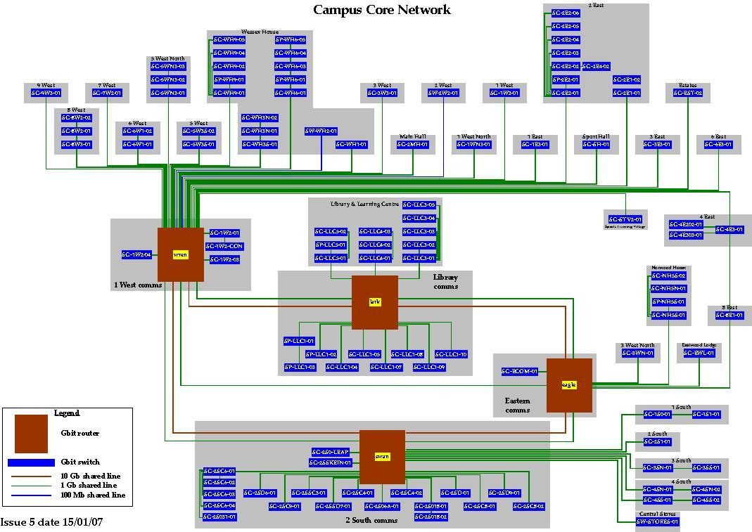
U of Bath Campus network

16. Networks
- No hosts shown: this is just the connectivity
- Multiple paths between points
- Gigabit and 10Gb links
- Other big networks, e.g., in CS, are not shown
- Connection to rest of world not shown

17. South West Regional Network
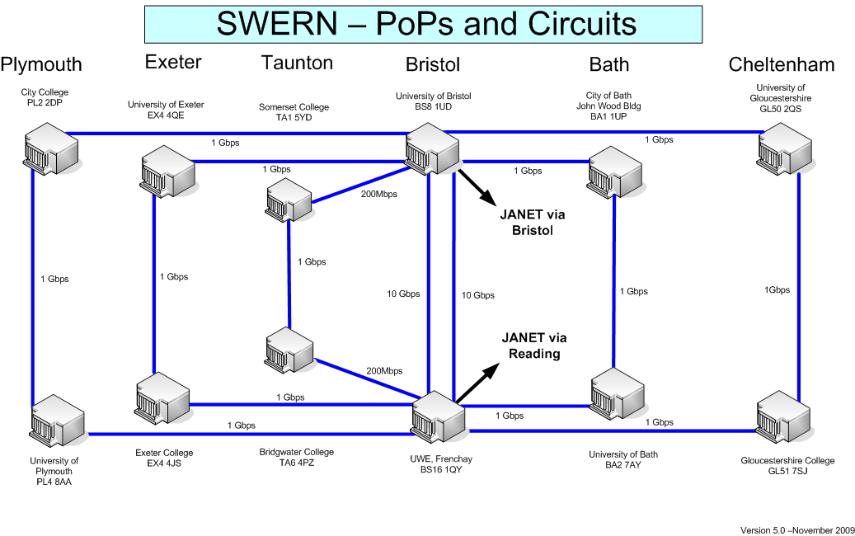
South West Regional Network (SWERN)

18. Joint Academic Network
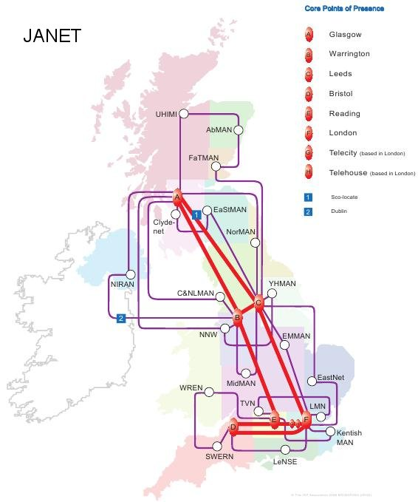
Joint Academic Network (JANET)

19. JANET
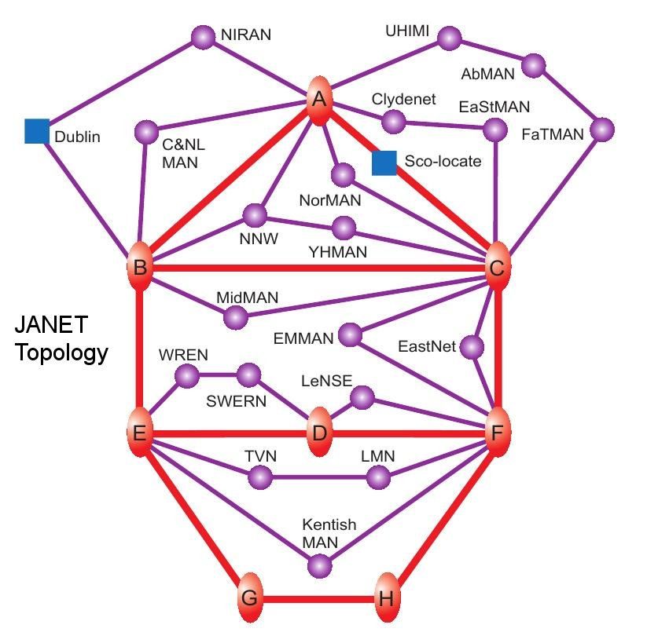
JANET Topology

20. Networks
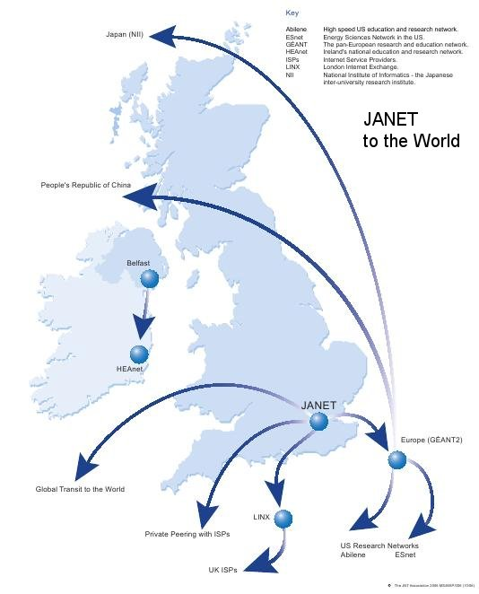
JANET connections to Internet

21. GÉANT
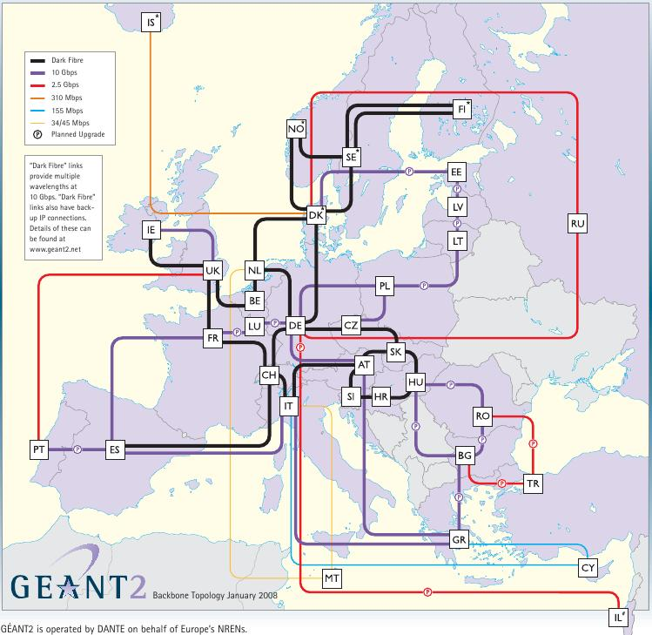
GÉANT European Network

22. CANARIE
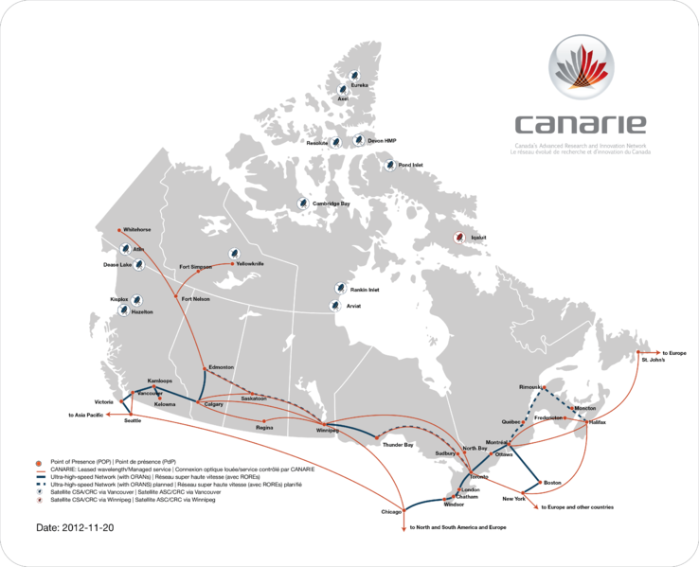
CANARIE network in Canada

23. Hierarchy
We can see the Internet is a hierarchy of networks, managed by different groups
- department
- university
- region
- country
- world
for example
And this delegation of control is essential to the way the Internet works

24. Networks

Important Points
The “Internet” (capital “I”) is the world-wide collection of networks
An “internet” (lower “i”), an abbreviation of “internetwork”, is just some collection of networks
An “intranet” (with an “a”) is some collection of networks belonging to a single organisation
The Web is not the Internet
Anyone caught saying so will be laughed at and will lose marks in the exam

25. Networks
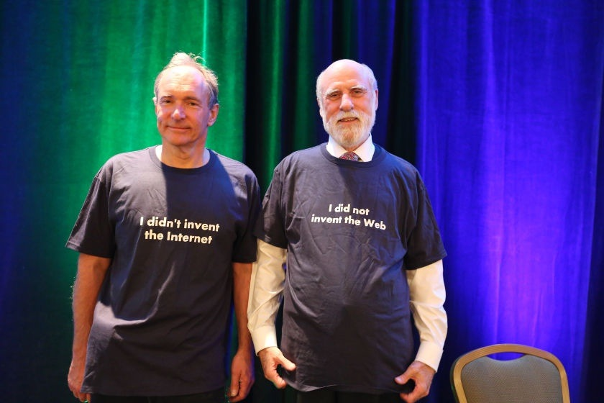
Tim Berners-Lee and Vint Cerf Front (photos from W3C)

26. Networks
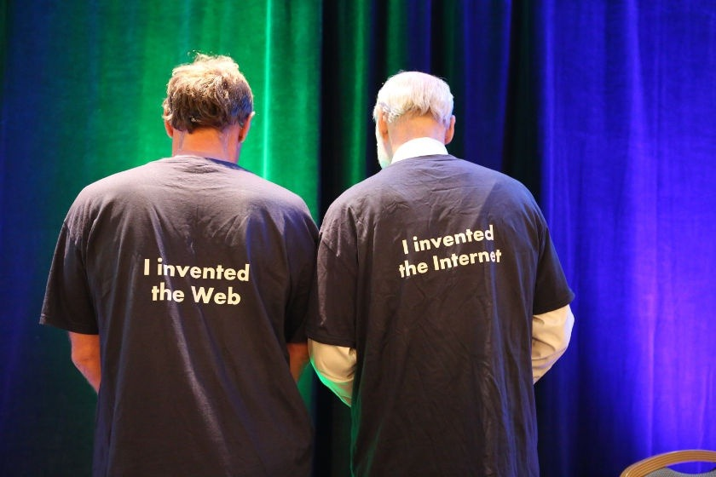
Tim Berners-Lee and Vint Cerf Back (photos from W3C)

27. Networks
The basis of the Internet is collaboration between its member networks
Data travels from source to destination by being passed from machine to machine; from network to network

28. Networks
traceroute to www.youtube.com (208.65.153.238), 30 hops max, 40
byte packets
1 fire.cs.bath.ac.uk (172.16.0.1) 0.166 ms 0.171 ms 0.216 ms
2 gw.cs.bath.ac.uk (138.38.108.254) 0.570 ms 0.448 ms 0.337 ms
3 swan-wren-10g1.bath.ac.uk (138.38.255.1) 0.430 ms 0.470 ms 0.352 ms
4 7200-bath.bath.ac.uk (138.38.1.1) 1.190 ms 1.431 ms 1.356 ms
5 fren-bath-ph.swern.net.uk (194.83.94.65) 3.198 ms 2.548 ms 2.515 ms
6 so-1-3-0.read-sbr1.ja.net (146.97.42.157) 7.978 ms 7.859 ms 8.305 ms
7 so-1-0-0.lond-sbr3.ja.net (146.97.33.142) 9.287 ms 9.468 ms 9.207 ms
8 195.219.100.13 (195.219.100.13) 9.320 ms 9.553 ms 9.760 ms
9 195.219.195.21 (195.219.195.21) 9.458 ms 9.401 ms 9.407 ms
10 ge4-1-0-1000M.ar3.LON2.gblx.net (64.208.110.81) 14.544 ms 17.433 ms
13.969 ms
11 te1-1-10G.ar2.SJC2.gblx.net (67.17.109.102) 165.984 ms 167.465 ms
169.402 ms
12 YOUTUBE-LLC.po1.401.ar2.SJC2.gblx.net (64.212.108.162) 165.040 ms
167.189 ms 165.938 ms
13 youtube.com.hk (208.65.153.238) 165.972 ms 165.825 ms 165.815 ms
gblx: Global Crossing; SJC: San José, California
youtube.com.hk is in San José

29. Networks
This was done just after a major problem with the route to Youtube (a mistake in Pakistan lead to chaos, February 2008)
Allegedly, the Pakistan government was trying to censor a Youtube video by blocking all routes to Youtube in that country, but the block escaped to the whole Internet
A little later things settled down again…

30. Networks
traceroute to www.youtube.com (208.65.153.238), 30 hops max, 40
byte packets
1 fire.cs.bath.ac.uk (172.16.0.1) 0.205 ms 0.210 ms 0.091 ms
2 gw.cs.bath.ac.uk (138.38.108.254) 0.446 ms 0.431 ms 0.341 ms
3 swan-wren-10g1.bath.ac.uk (138.38.255.1) 1.185 ms 0.841 ms 0.648 ms
4 7200-bath.bath.ac.uk (138.38.1.1) 1.247 ms 1.062 ms 1.214 ms
5 fren-bath-ph.swern.net.uk (194.83.94.65) 2.808 ms 2.438 ms 2.653 ms
6 so-1-3-0.read-sbr1.ja.net (146.97.42.157) 7.839 ms 8.265 ms 7.798 ms
7 so-1-0-0.lond-sbr3.ja.net (146.97.33.142) 9.526 ms 9.520 ms 9.726 ms
8 po1-0.lond-gw-ixp2.ja.net (146.97.35.250) 9.672 ms 9.338 ms 9.089 ms
9 195.66.226.185 (195.66.226.185) 9.804 ms 9.840 ms 9.926 ms
10 te7-3.mpd02.lon01.atlas.cogentco.com (130.117.2.26) 9.823 ms
te2-1.3493.mpd02.lon01.atlas.cogentco.com (130.117.2.18) 10.223 ms
te7-3.mpd02.lon01.atlas.cogentco.com (130.117.2.26) 9.685 ms
11 <snip>
19 * * *
20 youtube.com (208.65.153.238) 154.886 ms 156.732 ms 156.480 ms
Step 10: multiple probes go different routes
Step 19: a machine that refuses to respond to the probes
Host 208.65.153.238 is now named youtube.com

31. Networks
And again on 25 Sept 2017:
traceroute to www.youtube.com (216.58.204.14), 30 hops max, 60 byte packets
1 fire-private.cs.bath.ac.uk (172.16.0.1) 0.109 ms 0.097 ms 0.088 ms
2 gw-palo.cs.bath.ac.uk (138.38.108.254) 1.055 ms 1.048 ms 1.041 ms
3 bath-gw-1-palo.bath.ac.uk (193.63.64.174) 1.608 ms 1.800 ms 1.703 ms
4 xe-1-2-0.bathub-rbr1.ja.net (146.97.144.33) 1.287 ms 1.332 ms 1.330 ms
5 xe-1-2-0.briswe-rbr1.ja.net (146.97.67.65) 2.286 ms 2.720 ms 2.707 ms
6 ae22.londpg-sbr2.ja.net (146.97.37.201) 5.189 ms 4.652 ms 4.648 ms
7 ae29.londhx-sbr1.ja.net (146.97.33.1) 5.089 ms 5.037 ms 5.012 ms
8 193.62.157.22 (193.62.157.22) 5.270 ms 5.263 ms 5.246 ms
9 108.170.246.225 (108.170.246.225) 5.938 ms 5.928 ms 5.869 ms
10 108.170.238.145 (108.170.238.145) 5.907 ms
108.170.238.147 (108.170.238.147 6.141 ms 6.129 ms
11 lhr35s07-in-f14.1e100.net (216.58.204.14) 5.818 ms 5.820 ms 5.798 ms
Google are using a local server, probably in London

32. Networks
And again on 3 October 2019:
traceroute to www.youtube.com (216.58.198.174), 30 hops max, 60 byte packets
1 fire-private.cs.bath.ac.uk (172.16.0.1) 0.197 ms 0.174 ms 0.149 ms
2 gw-palo.cs.bath.ac.uk (138.38.108.254) 0.708 ms 0.682 ms 0.661 ms
3 bath-gw-1-palo.bath.ac.uk (193.63.64.174) 1.776 ms 1.531 ms 1.856 ms
4 xe-1-2-0.bathub-rbr1.ja.net (146.97.144.33) 1.074 ms 1.061 ms 1.047 ms
5 xe-1-2-0.briswe-rbr1.ja.net (146.97.67.65) 2.113 ms 2.103 ms 2.092 ms
6 ae22.londpg-sbr2.ja.net (146.97.37.201) 4.314 ms 4.329 ms 4.274 ms
7 ae29.londhx-sbr1.ja.net (146.97.33.1) 5.163 ms 5.878 ms 5.854 ms
8 193.62.157.22 (193.62.157.22) 5.587 ms 5.586 ms 5.544 ms
9 * * *
10 172.253.71.200 (172.253.71.200) 7.069 ms
108.170.238.118 (108.170.238.118) 6.627 ms
172.253.68.210 (172.253.68.210) 6.284 ms
11 74.125.242.114 (74.125.242.114) 8.502 ms
108.170.232.99 (108.170.232.99) 4.818 ms
74.125.242.82 (74.125.242.82) 5.622 ms
12 lhr25s10-in-f14.1e100.net (216.58.198.174) 4.574 ms
216.239.57.207 (216.239.57.207) 6.150 ms
209.85.250.185 (209.85.250.185) 7.028 ms
Now much more variation in routes and multiple servers!

33. Networks
Mistakes in routing are not just ancient history: 4th October 2021 Facebook dropped off the Internet for 6 hours
A “misconfiguration” meant that its name servers (converting names like facebook.com to addresses) were not accessible
This took out Facebook, Whatsapp, Instgram, Oculus, Messenger, etc., and any site that uses Facebook to login
To the extent that the keycards on the doors to the machine rooms that Facebook engineers needed to get into to fix the problem were also not working
And the engineers couldn’t message the security guards with the backup keys, either!

34. Networks

History
The reason for this cooperative design comes from the history of the Internet
- 1957: The Soviet Union launches Sputnik
- mid 1960s: Advanced Research Projects Agency (ARPA) formed. A project to share expensive resources: namely their computers
- The network design was to be non-centralised to avoid single points of failure, particularly nuclear attacks
- So there is no single point of coordination or oversight of the network
- And there must be multiple paths between hosts

35. Networks

History
Using simple circuits (such as the telephone system used) between machines would be too vulnerable, so packet switching was devised
Data is chopped into small chunks, called packets, and each packet is sent individually, possibly over different paths
Individual packets might get lost, but others will get through
The original data are reconstructed at the receiving host

36. Networks

Warning
The word is “packet”, not “package”
Take care never to use the word “package” in a technical context

37. Networks
- 1969 First Internet has just four nodes
- Runs NCP Network Control Program

38. Networks

History
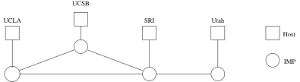
The Original Arpanet, 1969; Separate Interface Message Processors

39. Networks
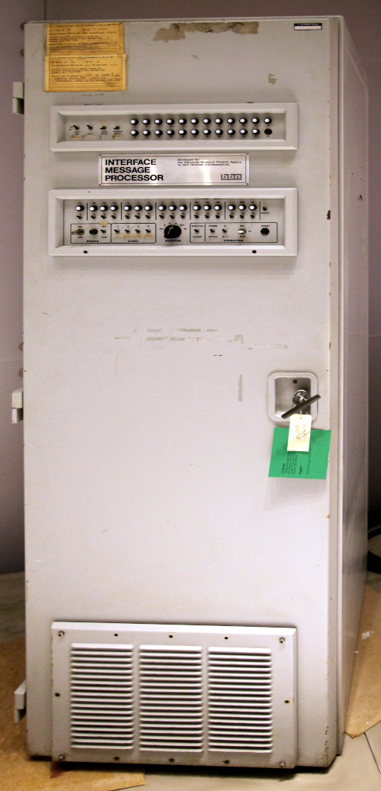
An Arpanet IMP (Wikipedia)

