Networking
CM30078/CM50123
Russell Bradford
2023/24

1. Networks

History
- Email and discussion groups are immediately popular
- 1973 Internet reaches London
- 1974 TCP/IP replaces NCP

2. Networks

History
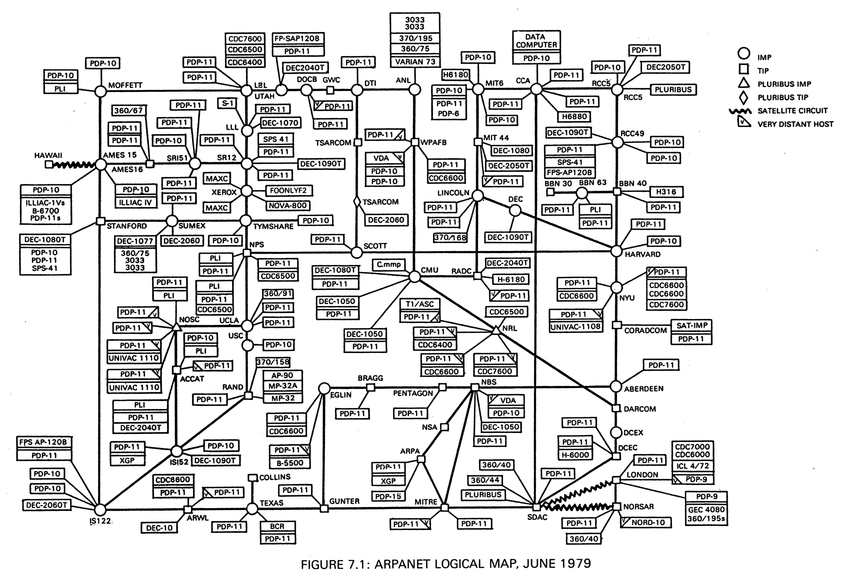
Arpanet in 1979, from “Computer Networks, Fundamentals, Practice”; Bacon, Stokes, Bacon, 1984

3. Networks

History
- 1980s 1000s of machines on the Internet
- Domain Name System arrives
- 1980/90 Original ARPANET decommissioned and replaced
- Commerce arrives
- Other networks based on other protocols are replaced by the Internet
- 1992 1,000,000 hosts
- Gopher
- Tim Berners-Lee invents the Web

4. Networks

History
- The Internet starts to enter the home
- Microsoft gives up on its own network and falls into line
- The Dot Com boom
- The Dot Com crash
- Broadband to the home
- Large commerce over the Internet

5. Networks

History
- Mobile revolution
- “Social” media
- Internet of Things (IoT); blockchain; etc.
- …what next?

6. Networks
Already this decentralised and packet nature has implications on how the Internet must work
- how to chunk the data into packets?
- how are route(s) the packets use to get to their destination found?
- how do we reconstruct the original data as packets might be arriving in any order?
And higher level decisions like how we shall choose and build these multiple routes; what hardware to use, and so on

7. Networks
A packet doesn’t know how to get to its destination
Even the source host doesn’t generally know a route to the destination (only if the destination is on the local network)
A packet is like a postcard with the address written on it: it relies on the routers it passes though to make the right decisions
“Please forward me to www.youtube.com”
It is not like a car driver with their own map making their own decisions!
The question now becomes: how do the routers know what to do? More on this later

8. Networks

Protocols
To ensure maximum interoperability, the Internet relies on standards and standardised protocols
The use of standards means that machine A will be able to communicate with machine B even if A and B are made by completely different companies, are of completely different technologies and have never previously interacted
It is clear that you must have standards for interoperability in hardware: you can’t plug a electrical plug into an optical socket
But you must have standards in the software too, as becomes clear when you try to use a Web page authoring tool that doesn’t produce standard HTML
Thus we must have standards for the protocols

9. Networks

Protocols
This is somewhat akin to people agreeing all to use English (for example) to communicate
A pair of random people meeting can talk if they both know English
If not, the chances are that they share their native languages are quite small

10. Networks

Protocols
The Internet has a collection of specifications called Request for Comments, or RFCs
RFCs are freely available on the Internet for everyone to read and implement
The RFC philosophy:
Be as close to the RFC as possible in what you do yourself, but be as liberal as possible regarding what you accept from others
Continuing Exercise When a topic is covered in lectures, read the relevant RFCs

11. Networks

Protocols
There are several bodies that oversee the structure and working of the Internet and the standards
- Internet Society (ISOC); oversees the Internet standard development processes
- Internet Architecture Board (IAB); ISOC committee that oversees the technical and engineering development of the Internet, particularly IETF and IRTF
- Internet Engineering Task Force (IETF); IAB committee that develops standards and publishes RFCs
- Internet Engineering Steering Group (IESG); executive sub-committee of IETF that has final say over RFCs

12. Networks

Protocols
- Internet Research Task Force (IRTF); IAB committee that does long-term research and development of Internet technology
- Internet Research Steering Group (IRSG); sub-committee of IRTF that manages the research groups
- Internet Corporation for Assigned Names and Numbers (ICANN); nonprofit internationally-organised organisation to oversee (sets policy) for global resources such as names and numbers or other identifiers
- Internet Assigned Numbers Authority (IANA); an affiliate body to ICANN that actually manages the domain names, IP addresses and other things, currently run by a company named “Public Technical Identifiers”

13. Networks

Protocols
IANA delegates management of various things to Regional Internet Registries (RIRs), e.g., domain names and addresses
Current RIRs:
- African Network Information Centre (AfriNIC); Africa
- American Registry for Internet Numbers (ARIN); North America and Antarctica
- Asia-Pacific Network Information Centre (APNIC); Asia, Australia, New Zealand
- Latin America and Caribbean Network Information Centre (LACNIC); South America
- Réseaux IP Européns Network Coordination Centre (RIPE); Europe, Russia, the Middle East, and Central Asia

14. Networks

Protocols
These are geographical, not political, regions
The RIRs further delegate things like management of domain names to commercial companies
E.g., 123-reg, GoDaddy and hundreds of others
Exercise Trace the movement of money up this hierarchy

15. Networks

Protocols
Outside ISOC, others important specification bodies include
- IEEE Institute for Electric and Electronic Engineers; hardware like Ethernet and Wi-Fi
- ISO International Standards Organisation; e.g., XML standards
- IEC International Electrotechnical Commission; e.g., Digital Living Network Alliance (DLNA)
- ITU-T Telecommunication Standardization Sector of the ITU (International Telecommunication Union); e.g., DSL standards
- lots more national and international institutions, such as the British Standards Institution (BSI)

16. Networks

Protocols
There is quite a lot of overlap in what these institutions cover
Sometimes one institution will take a standard from another institution and put a new cover sheet on it and give it a new name or number
For example, the JPEG standard, from the Joint Photographic Experts Group, is the same as ISO standard 10918-6:2013 and ITU-T T.872
Exercise Investigate these standards bodies

17. Networks

History
Anyway, we need a common “language” (the protocols) for a network
For the Internet, this common language is called the Transmission Control Protocol/Internet Protocol (TCP/IP)
This name is more historical than accurate, but to see what it means we need to think of layers

18. Networks

Layering Models
What do we need to make two computers communicate?
We need to connect them, so there must be some kind of physical (electrical, optical, radio or other) thing between them
So they must be compatible on voltages, how bits are represented as electrical or optical signals, etc.
And they must agree on how to represent data as bits: recall the different ways of representing signed and unsigned integers; similarly there are several ways of encoding alphabetic characters as bits
And the same problem for all other kinds of data: how to represent that sound or that shade of blue?

19. Networks

Layering Models
And technical requirements we have of the network
Such as do we make sure data arrived safely and didn’t get lost or corrupted in transmission?
And a lot of other problems that only become clear when you try to build a network
Getting this right all at once is very difficult

20. Networks

Layering Models
So how should we implement a network system?
First we need a standard to follow
So how should we design a network standard?
The standard must address all the issues (and more) mentioned previously

21. Networks

Layering Models
This is too big a problem to be tackled all at once
How about chopping the design into chunks, each chunk having a well-defined functionality?
Note this is just the way we approach writing large programs
Except we are not writing a program here, we are designing a standard
So we slice the problem into nice, bite-size pieces, called layers

22. Networks

Layering Models
So what should the chunks be?
A layering model for a system is a suggestion on how you might want to slice up the problem of designing it all
An oft-misunderstood point is that a layering model is not a networking standard
It is a recommendation on how you approach the design of the standard
After you have written the standard, you can then make implementations

23. Networks

Layering Models
So:
- We pick a layering model
- We use this to guide us in making a standard
- We use the standard to direct the implementations
- We can then use the implementations
Note that there will likely be several differing implementations
But, if it is a comprehensive standard, and if all the implementations follow the standard, they will interoperate

24. Networks

Layering Models
For networks, there are two main layering models in use: the ISO Open Systems Interconnection (OSI) Seven-Layer Model; and the Internet Four-Layer Model
That is: two popular recommendations on how to design a networking standard
The OSI model is widely used while the Internet model is not, despite closely mirroring the Internet standard

