Networking
CM30078/CM50123
Russell Bradford
2023/24

1. CSMA/CA
The Hidden Host Problem means 802.11 can’t use CSMA/CD, like wired Ethernet
Instead, it uses carrier sense, multiple access, collision avoidance (CSMA/CA)
This is similar to CSMA/CD, but with a big difference
- Carrier sense: to deal with the common case of non-hidden hosts, first listen for a signal
- If free, send a packet
- If busy, wait until the end of the transmission and then enter a contention period: wait a random period
- Go back to carrier sense

2. CSMA/CA
Waiting for the contention period is the collision avoidance
A random wait mean that several hosts wanting to transmit are unlikely to all start transmitting simultaneously
We are trying to avoid a collision in advance rather than detect one after the fact: we know that signal detection is problematic in Wi-Fi
But collision avoidance does not guarantee no collisions, particularly with hidden hosts, so we need more

3. CSMA/CA
Thus, on successful receipt of a packet, a destination host will broadcast an acknowledgement (ACK) packet
This is just a packet to inform the sender that everything worked well and there was, in fact, no collision or other loss
If the sender never gets the ACK, it will resend, starting from the CS again
This ACK is important, as measurements have found loss rates on the order of 30%
Note the ACK is also visible to everyone in range of the destination, giving extra indication to others when a transmission has finished

4. CSMA/CA
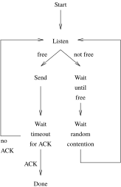
CSMA/CA flowchart

5. CSMA/CA
Exercise Compare and contrast the CSMA/CA flowchart with the CSMA/CD flowchart

6. CSMA/CA
Why use collision avoidance rather than collision detection?
Clearly, the contention period means more latency in transmission
We do it because with wireless, collisions can be very hard to detect
With Ethernet, detecting another host’s signal on a wire is easy as the power of its signal is roughly the same as yours

7. CSMA/CA
In contrast, detecting another host’s radio signal can be very difficult as it can be a tiny fraction of the power of yours, and your signal will drown out the colliding signal and make it undetectable
Recall the wide range of power that Wi-Fi signals encompass: another destination might be transmitting quite powerfully, but its signal can be very small by the time it reaches you

8. Wi-Fi
To help further with the visibility problem, there is optional RTS/CTS handshaking, which can improve performance in certain circumstances

9. RTS/CTS
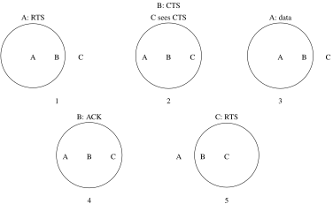
RTS/CTS handshaking
1. Before sending a data packet the source A can send a request to send (RTS) packet to B; 2. If the destination B is happy (it is not already receiving from another host that A cannot see) it responds with a clear to send (CTS) packet; 2. Every other host within the range of the destination will see the CTS and so know not to send themselves; 3. The RTS and CTS contain the length of the desired transmission so other hosts know how long they will have to wait; 4. Similarly, the final ACK is visible to everyone within range of B; 5. Then C can start with its own RTS

10. RTS/CTS
This means there is even more latency overhead before data starts to be transmitted, so RTS/CTS can be switched off or on as required:
RTS/CTS always on: good for large or busy networks
RTS/CTS never on: good for small or lightly loaded networks where every host can see all other hosts
RTS/CTS for large packets only: a compromise that reduces the relatively large overhead for small packets

11. Wireless Rates
Although 802.11b is nominally 11Mb/s and 802.11g is nominally 54Mb/s remember these are the signalling rates, not the data rates
The signalling rate is the raw bit rate over the airwaves: a lot of that is consumed in overheads
Realistically, 802.11b gives about 3 to 4Mb/s and 802.11g about 20Mb/s
Some of the later 802.11 standard improve speeds by reducing overheads (as well as using better encodings)

12. 802.11
Exercise 802.11ac (branded “Wi-Fi 5”) is common and 11ax (“Wi-Fi 6”) hardware becoming more common. Read up on what they promise and what they deliver

13. Wireless Networks
While the use of access points is common, this is not the only way to set up a wireless network
802.11 can be arranged in point-to-point networks called Ad-Hoc or Independent Basic Service Set (IBSS)

14. Wireless Networks
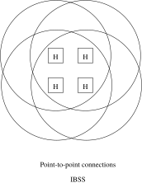
Ad-Hoc network
Each host communicates directly with each other without an access point
Clearly all hosts need to be sufficiently close to each other

15. Wireless Networks
But the usual Wi-Fi network is a Infrastructure or Basic Service Set (BSS), where a central hub (access point) relays traffic between hosts
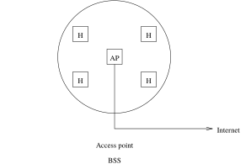
Usual access point setup

16. Wireless Networks
This is more expensive to set up (as you have to buy an AP), but covers a larger area
And is easier to manage by non-technical users
Also the AP can connect into a wired network and so the rest of the Internet

17. Wireless Networks
Extended Service Set (ESS) connects several APs by a wired network
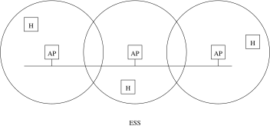
Extended network
This allows hosts to roam and things can be configured to handoff automatically between APs if the required authentication infrastructure is set up in the APs
An ESS can cover an area as large as you like

18. Wireless Networks
Exercise Read about Wi-Fi Direct, another peer-to-peer wireless connection between hosts, often used as a device setup mechanism. Compare with Ad-Hoc mode
Exercise Read about Mesh networks

19. Wireless Security
While we are talking about authentication…
Wireless packets are readable by anybody in the neighbourhood, so security is essential in a wireless network
We have two issues:
- is this machine allowed to connect to this network: authentication
- ensure data in transit is kept secret: privacy
On Ethernet, being plugged into the network is the “authentication”, while the physical security of the network is the “privacy”
But only private from people not on the network!

20. Wireless Security
Original 802.11 employed the Wired Equivalent Privacy (WEP) encryption scheme
Both ends of a communication share a secret key that is used to encrypt the traffic between them
WEP is now easily breakable: after collecting a modest amount of traffic the system can be broken
As can its successor, Wi-Fi Protected Access (WPA)

21. Wireless Security
Currently we use mostly WPA2, (IEEE 802.11i-2004)
Exercise Read about the break of the WPA2 protocol (Oct 2017)
Exercise Read about the new WPA3

22. Wireless Security
Two major ways to set up authentication are
- WPA-Personal: also called WPA-PSK (pre-shared key), where an access point has a secret key, and a host authenticates directly with the AP using the secret key
- WPA-Enterprise (802.11X): requires a separate authentication server (typically a RADIUS server) that the AP will contact. Much more fiddly to manage, but allows roaming across an ESS. Also roaming across institutions using hierarchical RADIUS servers
We usually find BSS using WPA-PSK and ESS using WPA-Enterprise, but either can use either

23. Wireless Security
For WPA-PSK the secret key is usually derived from a password for ease of use
The password is communicated off-line, e.g., written down somewhere
Everybody on the network shares the same key/password; authentication is done in the AP
WPA-Enterprise is more complex

24. Wireless Security
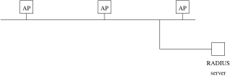
RADIUS authentication
Access points do not authenticate, but ask a RADIUS server

25. Wireless Security
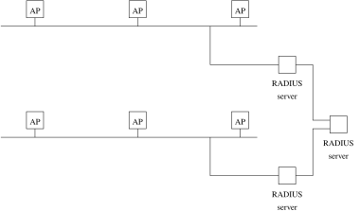
Multi-institution

26. Wireless Security
For WPA-Enterprise each user has their own key/password
Authentication is done in the RADIUS server on both the username and the password

27. Wireless Security
Exercise Read about how Eduroam uses WPA-Enterprise
Exercise Read about RADIUS: Remote Authentication Dial In User Service

28. Wireless Security
Some APs have Wi-Fi Protected Setup (WPS), a simplified way of setting up WPA/WPA2 security
Designed for those people who find typing in a password too challenging
It is seriously broken and should be disabled on your AP
Exercise A common system we see on public Wi-Fi is a redirect to a login web page: sometimes called a captive portal. What kind of security (privacy and authentication) does this provide? Note this is not WPA-Enterprise

29. Wireless 802.11
The frame layout for Wi-Fi is the same as Ethernet
In particular it has the same format MAC addresses, e.g., 00:04:ed:f1:ef:8a
This allows the transparent mixing of Wi-Fi and Ethernet in a single network
An AP can pass on a Wi-Fi frame unchanged to an Ethernet; and vice versa
Exercise What implication does this have for Ethernet collision domains?

30. PHY Sublayers
This is a good argument for sub-dividing the physical layer!
Exercise For hardware hackers: read about the IEEE layers:
- Physical Medium Attachment (PMA) for things like frames
- Physical Coding Sublayer (PCS) for things like 4B/5B
- Physical Medium Dependent (PMD) for the hardware
But it does mean we don’t have to discuss Wi-Fi any further!

31. Other Wireless
Many other wireless networks exist, from local to wide-area

32. Other Wireless
Bluetooth gives short range, point-to-point communication
Point-to-point: just two hosts in the network
A range of 10m
Also uses 2.4GHz band
Not really designed to run IP, but can by layering a suitable protocol (see PPP, later)
Bluetooth Low Energy (BLE), is a non-backwards-compatible evolution designed to reduce power consumption

33. Other Wireless
Exercise Read about Adaptive Network Topology (ANT and ANT+) for short range low power wireless, similar to BLE, but for use with fitness (and other) sensors (by Garmin)
Exercise Read about Zigbee for short range low data rate, low power wireless, for use in home automation and control

