Networking
CM30078/CM50123
Russell Bradford
2023/24

1. TCP

TCP State
The various stages a TCP connection can be in (setting up, tearing down, transmitting data, etc.) are complicated
There is a standard TCP state diagram that describes how TCP should act in most cases
Though it only covers non-error cases: it does not say what to do if, say, a SYNFIN segment arrives
And it shows little about timeouts and retransmissions

2. TCP

TCP State
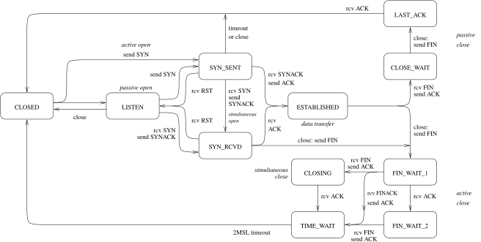
TCP State Diagram

3. TCP

TCP State
We start (and end) in CLOSED
There are the two opens: active and passive
LISTEN is a server waiting for a connection
ESTABLISHED is the normal data transfer state
And the two closes: active and passive
This state diagram is followed for each end of a connection, i.e., each socket in the socketpair

4. TCP

TCP State
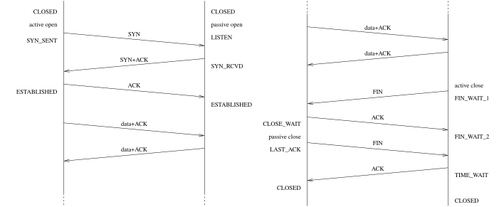
Typical TCP Timeline

5. TCP

TCP State
The active close is somewhat complicated by the need for reliability
The TIME_WAIT state (also called 2MSL state) appears before the final close: the active-close end of the connection must remain non-closed until a time period has passed

6. TCP

TCP State
TCP State Diagram

7. TCP

TCP State
At this point this end of the connection has received a final ACK and sent its final ACK
In a perfect world this would be enough to close the connection
But we have to deal with the case of the final ACK being lost
And resent if it didn’t get to the other end

8. TCP

TCP State
Just because the application is done with the connection, it doesn’t mean the connection is finished and the OS can discard all the connection state
The maximum segment lifetime (MSL) is a value that represents the longest time a segment can live in the network before being discarded (probably through TTL expiry)
This was originally defined to be 2 minutes, but implementations often choose smaller values, like 60 seconds
A TCP connection is required stay in TIME_WAIT for twice the MSL

9. TCP

TCP State
This is in case the final ACK (of the final FIN) was lost and needs to be retransmitted
The OS has to keep the connection hanging around for a little to cover this case
Even if the process that used the connection has exited
And while in this wait state if a new process tries to make a connection using the same ports it will be denied: the old connection is still active. We don’t want to deliver late packets to the new process
In this sense the TCP connection and the process using it are quite separate entities

11. TCP

Teardown
When an application exits, the OS sends FINs on behalf of the application for all currently open connections. This makes sure everything is tidied up nicely (even if the programmer didn’t)
And if it was an active close, OS needs to hold the connection in the 2MSL state for a while: the connection definitely outlives the application!
If a host is shut down normally, rather than crashing, the operating system will (should!) send FINs for all currently open connections
It really should do the TIME_WAIT, but often implementations don’t bother as this would hold up the shutdown

12. TCP Strategies
We now take a look at how TCP manages to get the best out of a connection
For example: TCP gets reliability by acknowledging every byte sent. Does this mean two segments for every data packet: one data packet out, one ACK packet back?
It is possible to implement TCP like this, but performance would be poor
So a typical TCP implementation will be a bit more smart on its use of ACKs: we have already mentioned delaying an ACK to let it piggyback on a returning data segment

13. TCP Strategies
That is just first of many strategies a TCP implementation can employ while still following the TCP protocol
We shall look at a few basic strategies, starting with more detail on the advertised window

14. TCP Strategies

Advertised Window
As data arrives at its destination the OS puts it into a buffer, ready for the receiving application to read it. We have already seen the TCP advertised window in a returning segment which indicates how much of this buffer space is left
The space left depends on
- how fast the sender is sending the data
- how fast the application is reading the data
If the data arrives faster than it is read, the buffer will fill up

15. TCP Strategies

Advertised Window
The advertised window is how TCP tells the source to slow down or speed up
It is a sliding window mechanism, used as a form of flow control
Imagine the bytes being sent as a long stream, starting at byte 0 (actually byte $n$, given by the initial sequence number) and going up
A sliding window describes the range of bytes in the stream the sender can transmit next

16. TCP Strategies

Advertised Window
As the window gets smaller, the sender should send more slowly
As the window gets bigger, the sender can send more quickly
The sender recomputes the space available in the receiver every time it receives an ACK

17. TCP Strategies

Advertised Window
The left hand edge of the window is defined by the acknowledgement number in the latest ACK
The right hand edge is then given by adding on the size of the advertised window
The window size is sent in every ACK segment
As more ACKs are received, the window closes as the left edge advances

18. TCP Strategies

Advertised Window
As the application reads data, the window opens as the right edge advances
Rarely, the window can shrink (right edge recedes), perhaps if the buffer shrinks due to the memory being needed elsewhere

19. TCP Strategies

Advertised Window
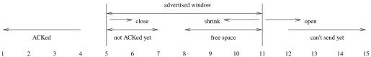
TCP sliding window
This is from the point of view of the sending end of a connection; The situation is that we have just sent a segment with bytes 5-7; then received an ACK of 5 with a window of 7; Bytes to the left of the window (1-4) have been ACKed and are safe in the destination; The advertised window tells us there is space for 7 bytes in the destination: bytes to the right (12 onwards) cannot be sent yet as the destination has nowhere to put them; Bytes within the window are either not ACKed yet, or represent free space; unACKed bytes (5-7) are those that have been sent by the sender, possibly received by the destination, and an ACK not yet received by the sender and possibly not yet sent by the receiver; The free space (8-11) is the actual number of bytes that the sender can be sure that can be buffered; The sender can compute this free space as the latest window value minus the number of bytes sent but as yet unACKed; Thus the sender knows the limit on how much more data it can currently send

20. TCP Strategies

Advertised Window
It is not unusual for the window to reduce to 0, for example when the destination application is reading its data slowly
The sender will have to wait before sending more data
When the receiver is ready to receive more data it will send a duplicate ACK with the same ACK number as the ACK with window 0, but now with a non-zero window: this is a window update segment
It may or may not contain data itself
Complications arise if this window update gets lost: the Persist Timer (see later) is used here

21. TCP Strategies

Delayed ACKs
The next strategy we have mentioned before
Instead of immediately ACKing every segment, we can slightly delay it and piggyback it on returning data

22. TCP Strategies

Delayed ACKs
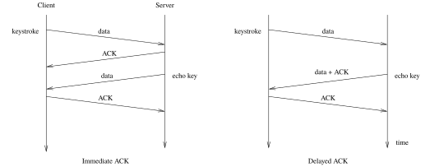
Immediate vs. delayed ACK
For example, when logged in to a remote terminal each keystroke is echoed back to your screen; An immediate ACK would use four segments; A delayed ACK piggybacking on the data for the echoed key uses just three segments

23. TCP Strategies

Delayed ACKs
As far as the user is concerned, they see the keystroke echo in the same way, with no extra delay, but fewer segments are sent
It is important to reduce the traffic on a heavily loaded network
It also reduces the chance of a lost segment

24. TCP Strategies

Delayed ACKs
By delaying, we might also be able to ACK more than one segment at a time
If we receive, say, two segments in a period we are delaying, we can simply ACK the last segment: this implicitly ACKs the previous two segments
An ACK is actually about acknowledging bytes, not acknowledging segments, but will usually align with segments
So an ACK indicates which byte we are expecting next and says all previous bytes have been safely received
This reduces traffic again

25. TCP Strategies

Delayed ACKs
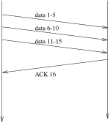
ACKing bytes received
ACKs acknowledge bytes received, not segments

26. TCP Strategies

Delayed ACKs
So how long to delay an ACK?
If too long, the sender might think the segment was lost and resend
If too short, we do not get so many free piggybacks or multiple ACKed segments
A typical implementation will delay for up to 200ms

27. TCP Strategies

Delayed ACKs
The TCP specification says you should send an ACK for at least every second full-sized segment and you must not delay for more than 500ms
This one of the many timers associated with TCP
Each time you receive a data segment the TCP software should set a timer for that segment that expires after 200ms

28. TCP Strategies

Delayed ACKs
If the segment has not already been ACKed (e.g., on a returning data segment), ACK it when the timer expires
Many operating systems have a single global timer that fires every 200ms rather than a timer per segment received
When the timer goes off, all unACKed segments are ACKed
Not so accurate as per-segment timers, but much easier to implement

29. TCP Strategies

Delayed ACKs
There is another rule concerning delayed ACKs
If you get an out-of-order segment (its sequence number is not the one you are expecting next, e.g., a segment was possibly lost), you must not delay, but send an ACK immediately
This might well be a duplicate ACK of one you sent earlier. This is to inform the sender as soon as possible that something might have gone wrong
Though the other end will wait for three duplicate ACKs just to be sure before resending

30. TCP Strategies

Nagle
Next strategy: when sending keystrokes (or other small data) over a network there is a lot of wasted bandwidth
A keystroke could be 1 byte
This is sent in a TCP segment that has 20 bytes of header
This is contained in a IP datagram with 20 bytes of header
And so on down the layers

31. TCP Strategies

Nagle
So we are sending (for the sake of argument) a 41 byte packet for each byte of data
Such a packet is called a tinygram
The proliferation of tinygrams causes additional congestion in a network
Nagle created a strategy for reducing this
It applies to the sender of the tinygram (client)

32. TCP Strategies

Nagle
Nagle’s Algorithm:
a TCP connection can have only one outstanding unACKed small segment: no additional small segments can be sent until that ACK has been received
If you are sending tinygrams, only send one and wait until you get its ACK before sending any more
Any small segments waiting to be sent should be collected together into a single larger segment that is sent when the ACK is received

33. TCP Strategies

Nagle
This segment can also be sent if either (a) you collect enough small segments to fill a MSS segment, or (b) they have collectively exceeded half the destination’s advertised window size
This leaves open the definition of “small”
Variants choose anything from “1 byte” to “any segment shorter than the maximum segment size”

34. TCP Strategies

Nagle
Note that when window scaling is in effect, “small” must be at least the size of the window scale factor, as we can’t advertise a window smaller than that
But that won’t be a constraint until the scale is bigger than a segment, e.g., $2^{10}=1024$, but $2^{11}=2048>1500$

35. TCP Strategies

Nagle
This is a very simple strategy and reduces the number of tinygrams without introducing extra perceived delay (over that delay there is there already)
The faster ACKs come back, the more tinygrams can be sent
When there is congestion, so ACKs return more slowly, fewer tinygrams are sent

36. TCP Strategies

Nagle
Nagle can reduce the number of segments significantly when the network is heavily loaded
On the other hand, sometimes buffering up tinygrams is not a good idea: e.g., in a graphical interface over a network, each mouse movement becomes a tinygram. Buffering the segments would cause the cursor to jump erratically
Nagle can be turned off for such cases

